DATABASE SYSTEM ENGINEERING AND DISTRIBUTED BACKEND DEVELOPMENT
Course Code: 25CS13002E
ROLL NO: 2520030108
NAME: SAHASRA

DATABASE CREATION
Query: CREATE DATABASE
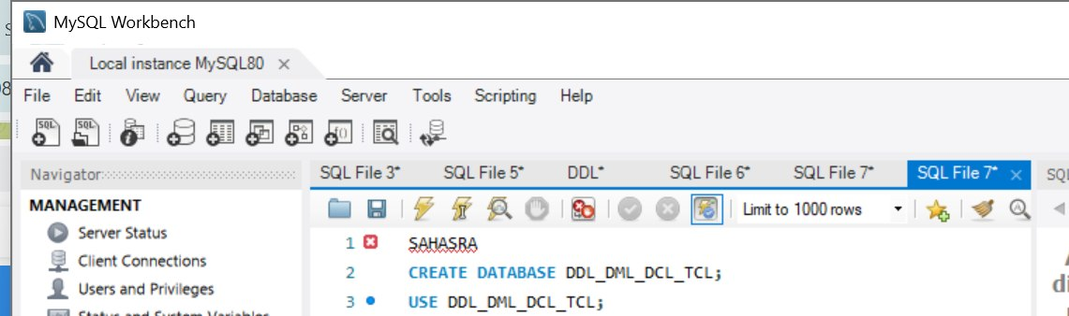
Output:
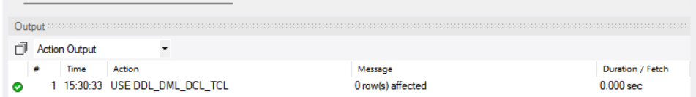
SECTION 1 : DDL (DATA DEFINITION LANGUAGE)
Query 1: CREATE TABLE
Query / Code:
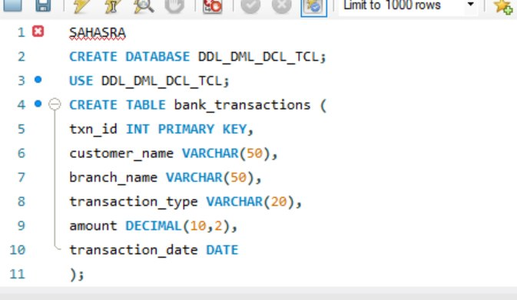

Output:

Query 2: ALTER TABLE ADD COLUMN
Query / Code:

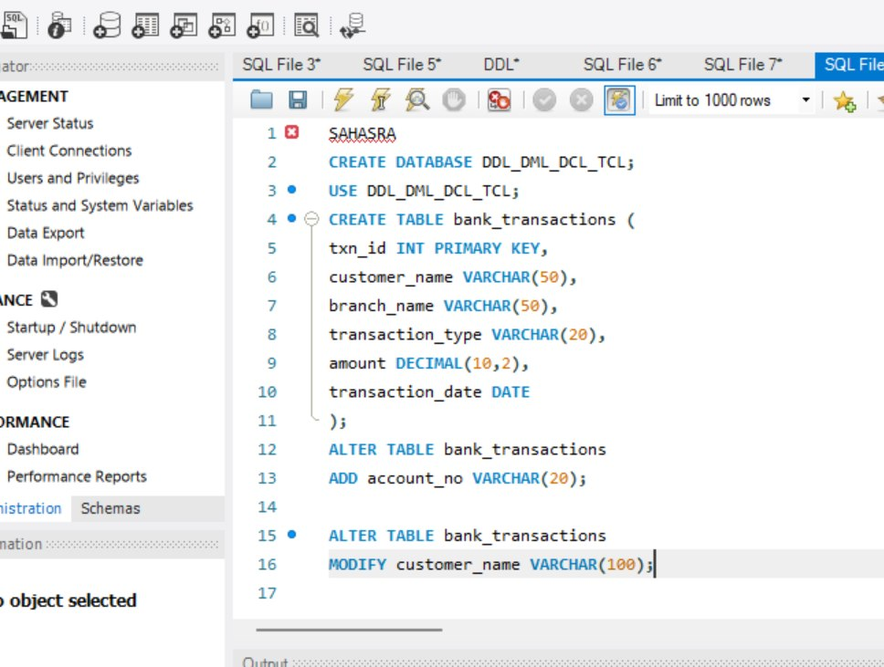
Output:

Query 3: ALTER TABLE MODIFY COLUMN
Query / Code:

Output:
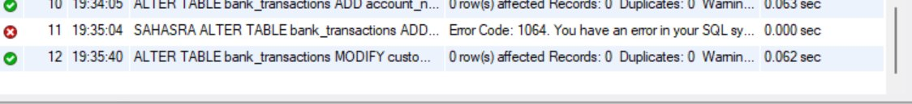

Query 4: RENAME TABLE
Query / Code:

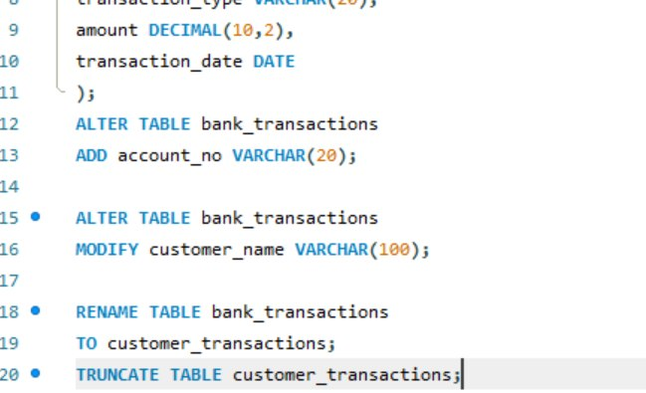
Output:

Query 5: TRUNCATE TABLE
Query / Code:

Output:

Query 6: DROP TABLE
Query / Code:

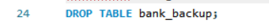
Output:

SECTION 2 : DML (DATA MANIPULATION LANGUAGE)
Query 7: INSERT
Query / Code:
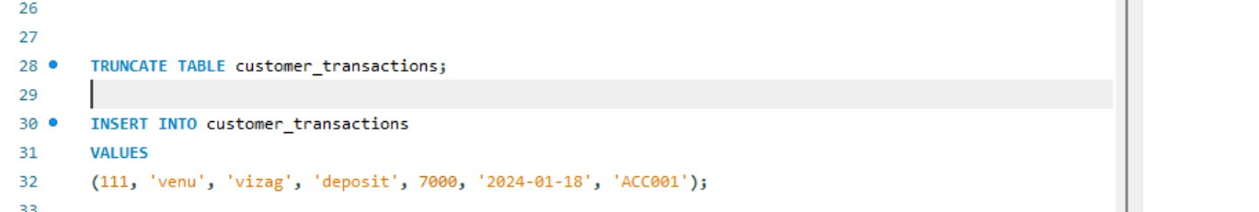
Output:

Query 8: UPDATE
Query / Code:
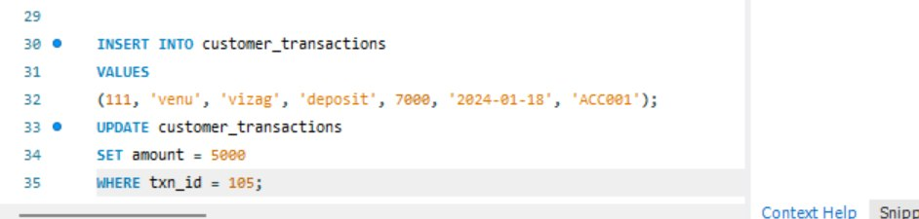
Output:

Query 9: DELETE
Query / Code:
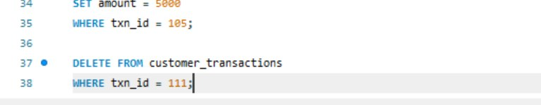
Output:

Query 10: SELECT
Query / Code:

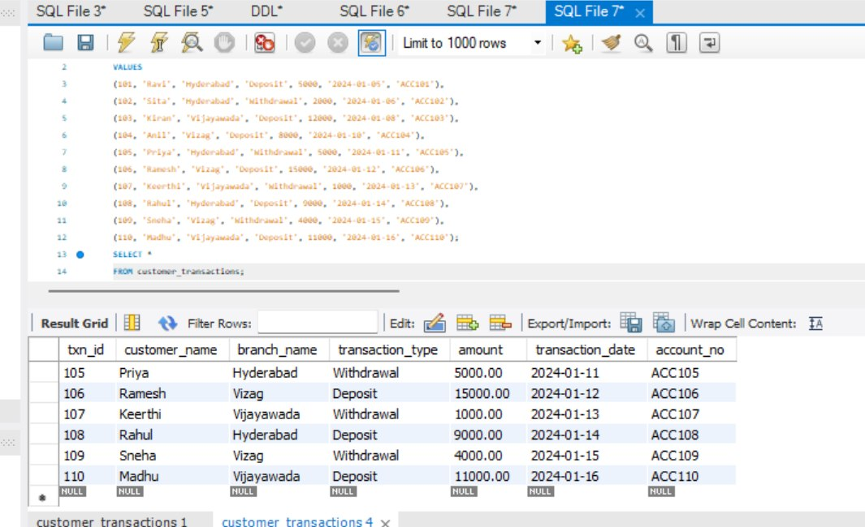
Output:

Query 11: SELECT WITH WHERE
Query / Code:

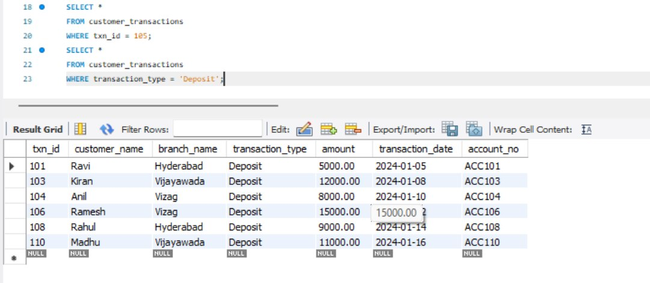
Output:

Query 12: SELECT WITH ORDER BY
Query / Code:

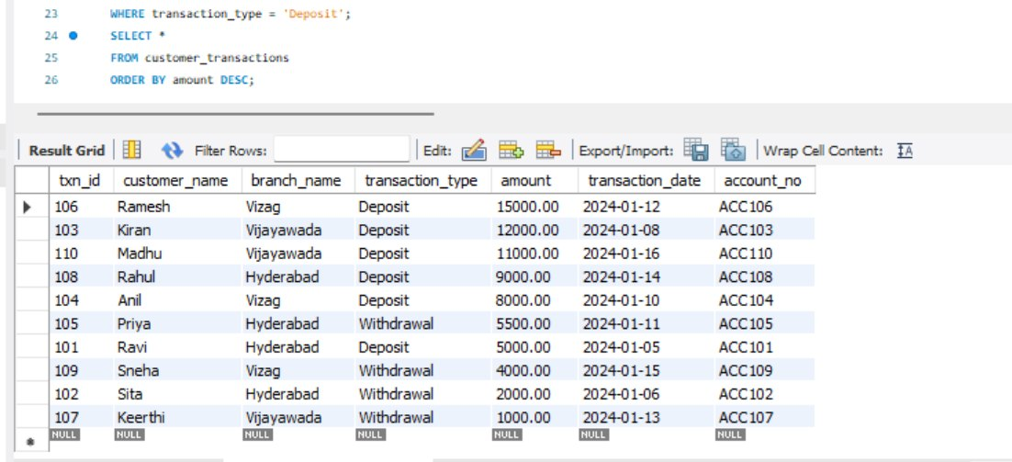
Output:

SECTION 3 : DCL (DATA CONTROL LANGUAGE)
Query 13: GRANT SELECT
Query / Code:
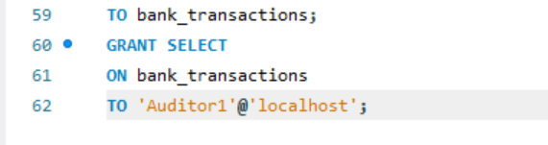
Output:

Query 14: GRANT ALL PRIVILEGES
Query / Code:
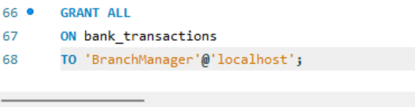
Output:

Query 15: REVOKE SELECT
Query / Code:
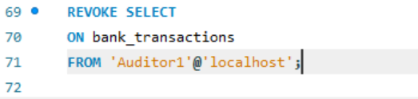
Output:

Query 16: REVOKE ALL
Query / Code:
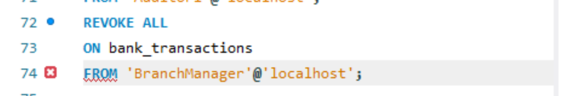

Output:

SECTION 4 : TCL (TRANSACTION CONTROL LANGUAGE)
Query 17: COMMIT
Query / Code:
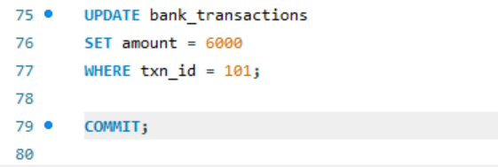
Output:

Query 18: SAVEPOINT
Query / Code:
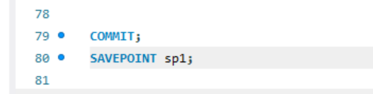
Output:

Query 19: ROLLBACK TO SAVEPOINT
Query / Code:
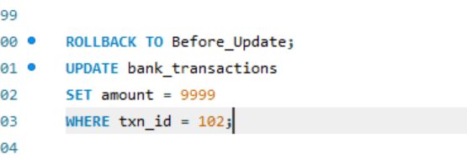

Output:

Query 20: FULL TCL EXAMPLE
Query / Code:
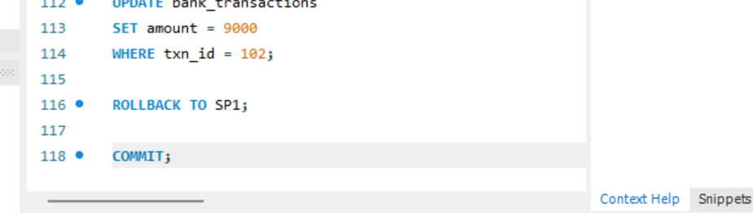

Output:

